Welcome to the Center for Government and
International Studies
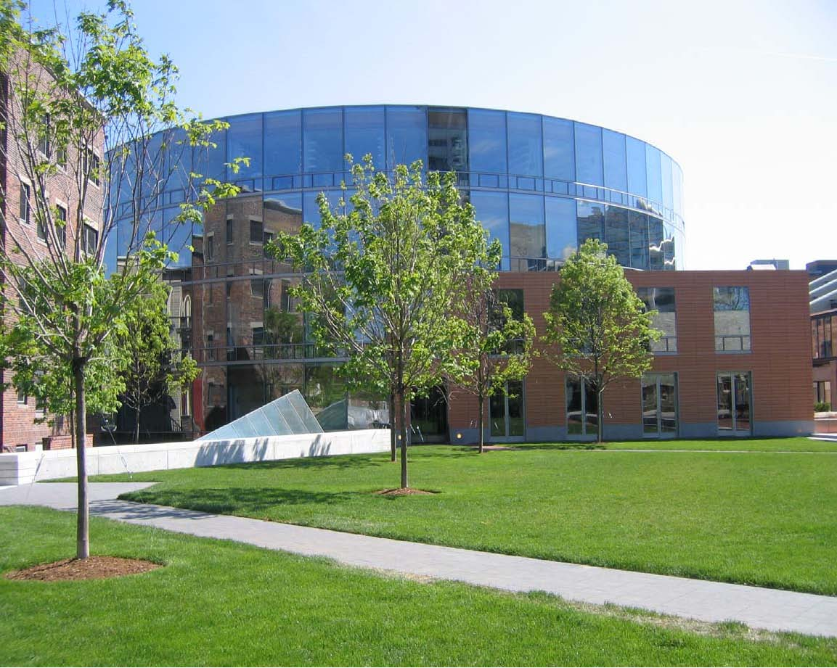
A Building Guide for Faculty and Staff

Art Exhibits – Rotating

Both CGIS South and Knafel offer unique exhibition opportunities: the Fisher Family Commons (FFC) Gallery and the Knafel Concourse Gallery in CGIS Knafel (first floor and concourse level, respectively) and the Japan Friends of Harvard Concourse (JFOHC) Gallery in CGIS South (concourse level). Interested parties should email Bettina Burch, Exhibit Coordinator, at bburch@fas.harvard.edu.Though CGIS-sponsored exhibits have precedence, other interested Harvard-affiliated groups, sponsors, or individual submissions are welcomed. More information can be found via the CGIS website.

Audiovisual and Equipment Assistance

The CGIS complex has an Audio-Visual support office located on the CGIS South Concourse Level in room #S-053. For support in rooms with A/V equipment installed, please email ess@fas.harvard.edu or call 617-495-9807. For more information about our department, hours, and policies, please visit us at https://ess.fas.harvard.edu .

Bicycle Racks

There are two bicycle racks on either side of CGIS South (44-bike capacity) and one near CGIS Knafel (16-bike capacity). Please do not lock your bike to the small trees around the CGIS complex.

Building Access Using Your Harvard ID

Your Harvard ID is also used to access spaces protected by a card reader, including the exterior doors. Department administrators are responsible for notifying CGIS Building Operations (bburch@fas.harvard.edu and cc: linda_kuczynski@fas.harvard.edu) of additions and deletions to the card access list. For all other ID-related services, please visit the Campus Services ID cards website.

Building Hours

CGIS's front doors are programmed by CGIS Building Operations. During the academic year, the doors are unlocked at the following times:

Knafel — 7:00 AM – 10:00 PM, Monday through Friday; and 1:00 PM – 9:00 PM, Sunday.
South — 7:00 AM – 10:00 PM, Monday through Friday
During break periods and the summer months, the doors are unlocked at the following times:
Knafel — 7:00 AM – 7:00 PM, Monday through Friday
South — 7:00 AM – 7:00 PM, Monday through Friday

Either building can be unlocked for evening or weekend classes or for special events by arrangement with CGIS Building Operations (617-495-9114).

Custodial Services

C&W provides custodial services for the CGIS complex. Office cleaning occurs weekly (Monday through Friday), Trash and recycling disposal occurs each night, Monday-Friday unless otherwise requested. Carpet washing is done once a year per request.

Twice Weekly (or as needed) Custodial Services

Occupant Areas: Empty and clean all waste receptacles
Vacuum rugs and carpeted areas

Restrooms: Empty and clean all waste receptacles
Sweep and disinfect floors
Disinfect all plumbing fixtures
Spot clean partitions
Restock supplies as needed

Public Areas: Wipe down doors, walls, and glass as needed
Empty and clean all waste receptacles
Vacuum rugs and carpeted area
Dust furniture as needed

If you have questions or comments about custodial services, please contact the Building Operations Office at 617-495-9114.

Day Porter Services

The day porter keeps the building clean throughout the day and assists with classroom setups and minor maintenance tasks. Special requests of the day porter should be made through CGIS Building Operations at 617-495-9114.

Disability Access

All CGIS space is accessible by wheelchair, except for 61 Kirkland Street, the upper floors of 34 Kirkland Street, and 17 Sumner Road.

Emergency Procedures

You should familiarize yourself with the emergency evacuation plans located throughout the buildings. There will be annual emergency evacuation drills. In case of a medical emergency, AED units are available in both the CGIS Knafel and South lobbies.

You can sign up to receive text message notifications in the event of a campus-wide emergency via the University Emergency Notification System at the following website: http://messageme.harvard.edu.

Filming
Filming and Professional Photography needs to have prior approval. Please visit Photographing and Filming on Harvard Property - Media Relations for more information.

Heating and Cooling

For the academic year all offices are programmed to heat up to 68F and cool down to 76F, during designated occupied hours.

Exterior offices (i.e., those with windows) are heated and cooled by individual fan coil units. If you are in your office outside designated hours and want to turn your fan coil on, press and hold (for 5 seconds) the sun/moon button on your thermostat. The fan coil will then stay on for 2 hours.

Interior offices do not have individual fan coil units, but rely solely on the main building air handlers to provide conditioned air. This is why the designated times are defined more generously for interior offices during the Academic Year, see following:

Exterior Offices: Monday through Friday, 8:00 AM – 7:00PM
Interior Offices: Monday through Friday, 8:00 AM – 7:00 PM; Sat and Sun, 9:00 AM – 5:00 PM

During the summer, the exterior offices are in unoccupied mode 24/7. To get cooling, you must press and hold (for 5 seconds) the sun/moon button and the fan coil will then stay on for 4 hours; and the interior offices have air-conditioning Monday through Friday, 9:00 AM – 5:00 PM.

Please note: If you have a weekend or evening event, you may contact CGIS Building Operations at 617-495-9114 or cgisroom@fas.harvard.edu to arrange for heating or cooling during the event.

IT Support

IQSS/HMDC Client Support Services provides local IT support to CGIS. We can be reached by phone at (617)-495-4734 or by email at help@iq.harvard.edu. For more details about all our services, please visit our website at https://iq.harvard.edu

Keys – Ordering

Requests for additional keys must be made through your CGIS department/center administrator via email or the online work order system PRESTO. Please supply relevant key codes and room numbers whenever possible. An email will be sent when keys are ready; keys should be picked up at CGIS K051 unless other arrangements are made.

Lactation Room

CGIS has a furnished, private, and secure room for use by lactating parents. You can register to use this or any other campus lactation room through the Office of Work Life. If any questions or local assistance particular to CGIS is needed, please contact a CGIS Ops member at 617-495-9114.

Loading Dock – Deliveries

The loading dock is open Monday through Friday, 7:00 AM – 2:00 PM. Maximum height of vehicles entering is 12’6”. Activity in the loading dock and at the curb cutouts in front of Knafel is overseen and managed the Loading Dock Coordinator, who is located in Knafel on the concourse level. If you have a special delivery or questions about the loading dock, please contact him at 617-495-8658.

Lock Out Policy

If you are locked out of your office during regular business hours, contact CGIS Building Operations at 617-495-9114. After hours, contact the security guard or call the Control Center at 617-495-5560.

Lost and Found

Please bring any found objects to CGIS Building Operations in K051.

If you have lost an item and would like to report it or see if it has been found, please contact us at 617-495-9114 or cgisroom@fas.harvard.edu, or stop by our office anytime during regular business hours (Monday through Friday, 8:00 AM – 5:00 PM).

At end of the semester any items still in our care will be donated to the Harvard Recycling Office.

Mail

Incoming mail is delivered to the central mail room in Knafel three times a day (Monday through Friday) at 9:15 AM, 11:00 AM, and 2:00 PM, and is then distributed to the department mail centers consistent with the following schedule:

10:30am-11:00am Delivery/Pick-up CGIS North/South
61 Kirkland St.
1:30pm-2:30pm Delivery/Pick-up CGIS North/South
17 Sumner St.
34 Kirkland St.
38 Kirkland St.
2:30pm-3:30pm Parcel Drop-off William James Hall
Delivery/Pick-up 61 Kirkland St. (last of day)
4:00pm-4:30pm Pick-up CGIS North/South

8:30am (next day) HUMS pick-up of previous day’s 4 pm items.

Outgoing mail is picked up from each departmental mail center at the time of delivery or can be dropped off at the central mail room in CGIS Knafel (concourse level).

St. Clair Lowe, the mail coordinator, also performs a daily courier route (e.g., to Smith Campus Center, 61 Kirkland Street, etc.). All mail going to Smith Campus Center is logged and signed for when delivered to the addressee. Courier routes can be tailored, if necessary, to meet departmental needs. Below are some examples of the proper way incoming packages should be addressed to ensure receipt:

Jane Smith
Government Department
CGIS Knafel Building
1737 Cambridge Street
Cambridge, MA 02138

John Doe
Asia Center
CGIS South Building
1730 Cambridge St.
Cambridge, MA 02138

Jane Smith
WCFIA
CGIS East
1727 Cambridge St.
Cambridge, MA 02138

Jane Smith**
WCFIA
61 Kirkland St.
Cambridge, MA 02138

**17 Sumner Rd., 34 Kirkland St. and 38 Kirkland St. should use the same address format as
61 Kirkland St.

Maintenance Requests

Routine maintenance requests should be made via the FAS Physical Resources daily maintenance work order page PRESTO. Any emergency requests should be called into the Control Center at 617-495-5560.

Meeting Rooms – Scheduling

The Office of the Registrar (617-495-1541 or classrooms@fas.harvard.edu) has scheduling authority over most of the public teaching space Monday through Friday, 9:00 AM – 10:00 PM, with a few exceptions. When scheduling rooms, they give first priority to courses taught by Government and History faculty and other faculty with offices in CGIS. The Teaching Fellow (TF) meeting rooms (S002A, S002B, and S002C) in the south concourse are scheduled by the Government Department.

The computer training room, K018, is scheduled via the Harvard-MIT Data Center (HMDC).
The remaining rooms are reserved by CGIS Room and both the Registrar and CGIS scheduled rooms must be scheduled via the Room Book website here. Due to overwhelming demand for CGIS meeting room spaces during the academic year, any classes and events scheduled must be affiliated with the Government Department, History Department, or sponsored by a Center or CGIS faculty member. Please see the Seminar Room Information Guide for photos of seminar spaces and detailed information on room capacity and multimedia capabilities.

Meeting Rooms – Use

After an event, please make sure you leave the room in good condition for the next group. If you bring anything into the room (e.g., food, beverages, catering supplies, papers, extra tables, folding chairs, etc.), please remove them from the room at the end of your meeting. If you serve food at your event, please wipe down the tables. Please also wipe the whiteboard down as needed. Additionally, while you are welcome to move the tables and chairs around to suit your group's needs, we ask that you return them to their original positions at the end of your event.

Please note: Food and drink are not permitted in either the Tsai Auditorium (S010) or the Belfer Case Study Room (S020). Amplified sound and music are not permitted in the South Concourse common event space. Exceptions will be granted if the sponsoring department has all South Concourse rooms and common space reserved.

Notices and Postering

Bulletin boards in common spaces are cleared of old materials every Monday morning. Please do not hang notices or posters anywhere but on the bulletin boards. Exception: On the day of your event you may put flyers or posters on the front doors of CGIS South or Knafel.

Parking

There is no parking anywhere in the CGIS complex. Please call the Parking Office at 617-496-7827 or visit Parking | Harvard Transportation & Parking with any questions. Under no circumstances should anyone park on the ramp to the loading dock.

Pets

Please be considerate of your coworkers and leave your pets at home.

Recycling

All offices, reception areas, classrooms, and meeting rooms have single-stream recycling bins, in addition to trash receptacles. Items such as batteries, keys, and printer cartridges may be dropped off at CGIS Building Operations in K051 for recycling, or recycled at one of the tower bins in the lobby of either CGIS South or Knafel. If you have a computer or monitor that needs to be recycled, please contact HMDC to arrange for this service.

Security

Monday through Friday there is a security guard stationed at the front entry of CGIS Knafel 4:00 PM – 12:00 AM, and in CGIS South 4:00 PM – 10:00 PM; on Sunday there is a guard stationed at the front entry of CGIS Knafel 1:00 PM – 9:00 PM, on days when the Fung Library is open. On weekdays there is a roving guard from 12:00 AM – 8:00 AM, and on Saturday and Sunday, from 5:00 PM – 7:00 AM.

On weekends, when the building does not have security coverage, departments are required to hire a security guard for large events that require the exterior doors to be unlocked. Event sponsors may be asked to hire a Harvard University Police detail if there are cash transactions. Questions about these policies should be directed to CGIS Building Operations at 617-495-3084.

Shipping and Receiving

All incoming express mail packages to Knafel, South, and East are delivered to the Loading Dock Coordinator, who then delivers them to the center drop-off points. Deliveries take place between 12:45 – 1:15 PM, Monday through Friday. Any packages that come in after 2:00 PM are dropped off at the Building Operations Office and will be delivered the following morning. Time-sensitive and expedited deliveries are delivered upon receipt. There are FedEx drop-off cabinets in the lobbies of CGIS South (under the bulletin board) and in Knafel (on the right side of the security desk). FedEx generally picks up from these locations at 6:00 PM, Monday through Friday.

Signage

Office signs must conform to building standards which can be obtained by contacting Bettina Burch (bburch@fas.harvard.edu) in CGIS Building Operations.

Smoking/Vaping

Smoking and vaping is prohibited in all Harvard buildings, Harvard Yard and the North Yard. The Sunken Garden on the concourse level of CGIS South is also off limits to smokers and vapers.
Vaping, whether it contains nicotine or otherwise, is considered smoking and is not allowed in buildings or within 25’ of a building entrance. Furthermore clouds of vapor may set off building fire alarms.

Teleconferencing

Departments wishing to conduct multi-user conference calls may borrow a Cisco 8831 IP Conference phone from CGIS Operations. Please consult the Conference Phone User Guide for details on its use. Questions? Call 617-495-3084.

Telephones

Telephone problems should be reported to Harvard University Information Technology (HUIT) at 617-495-7777 or ithelp@harvard.edu. You will need to provide a detailed description of the problem, the type of equipment being used, the telephone number, location, jack number, and a contact name and number.

Utilities

Please turn off all lights, fans, radios, desk lights, and task lights when leaving private offices and conference rooms. We need and appreciate your assistance in keeping utility costs down. When leaving your office for an extended period of time, please consider turning off all power strips and unplugging unnecessary items.

Vending Machines

There are vending machines located on the concourse level CGIS South and on the ground floor of CGIS Knafel next to the Fisher Family Commons. Payment can be made with cash or credit cards, as well as common touchless payments Apple Pay and Google Pay.

Website

For questions about or changes to the CGIS website, please contact Bettina Burch (bburch@fas.harvard.edu).

Window Blinds

There are motorized blinds installed on all exterior windows, programmed to open each morning at 7:00 AM and close each evening at 7:00 PM. Please make sure your hopper windows are closed by 7:00 PM and that no furniture is in the path of the blinds. If you have mechanical problems with the blinds, please call CGIS Building Operations Office at 617-495-9114.

Quick Reference Phone Guide
Building Operations Office 5-9114
CGIS Art Exhibit Spaces 5-0713
CGIS Classroom/Space Scheduling 5-3084
FAS Classrooms Office (Registrar) 5-1541
Harvard Control Center (24-hour response) 5-5560
Harvard Police 5-1212
Knafel Security Desk 5-8667
Mail Room 5-8659
Harvard Telephone Office 5-4900
Loading Dock Coordinator 5-8658
Parking Office 5-3772
Audio/Visual Support 5-9807
IT Support 5-4734

